**Project Design Phase-I**

**Technology Architecture**

|  |  |
| --- | --- |
| Name | Ganga devi (Team Lead)  Abinaya  Nagalakshmi  Balapraveen |
| Date | 26 October 2022 |
| Team ID | PNT2022TMID32983 |
| Project Name | Project – Smart Solutions For Railways |
| Maximum Marks | 4 Marks |

**Technical Architecture**

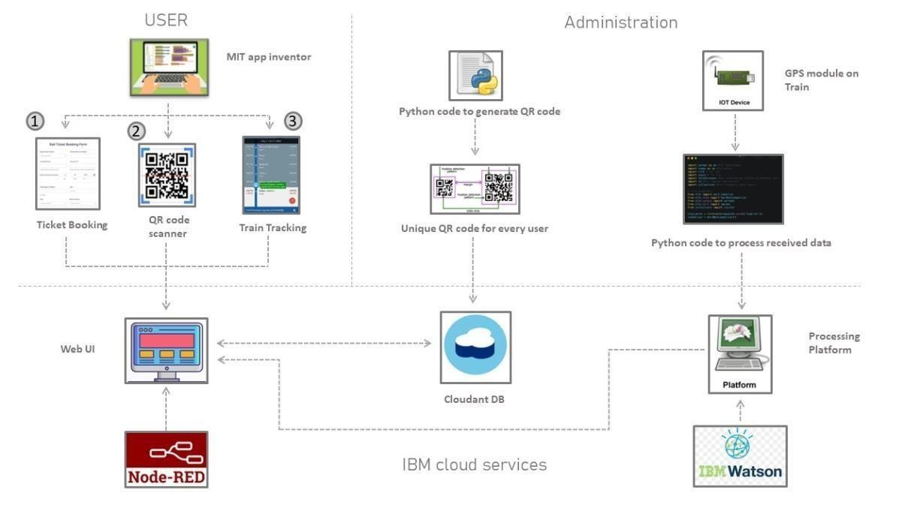

**Table-1 : Components & Technologies:**

|  |  |  |  |
| --- | --- | --- | --- |
| **S.No** | **Component** | **Description** | **Technology** |
| 1. | User Interface | User(Passenger or TTE) opens the website which is an application. | MIT app inventor |
| 2. | Application Logic-1 | Login as a passenger and book a ticket. | Web UI using Node RED service |
| 3. | Application Logic-2 | Login as a passenger and track the live status of a train. | Web UI using Node RED  service |
| 4. | Application Logic-3 | Login as TTE and scan a QR code to verify a ticket | Web UI using Node RED  service |
| 5. | QR code generator | A unique QR code is generated for booking each ticket and is stored in cloud database. | Python |
| 6. | Cloud Database | Database Service on Cloud to store passenger details and generated QR codes. | IBM Cloudant |
| 7. | IoT device(GPS module) | Fixed on the train to track the current location | Python |
| 8. | Processing Platform | Processes the data obtained from IoT device and displays it on Web UI | IBM Watson platform |

**Table-2: Application Characteristics:**

|  |  |  |  |
| --- | --- | --- | --- |
| **S.No** | **Characteristics** | **Description** | **Technology** |
| 1. | Open-Source Frameworks | Node RED , python 3.7 , cloudant  DB | Javascript, NoSQL , DBaaS |
| 2. | Security Implementations | All services include network and storage encryption, security information and event management. | IBM QRadar, OWASP. |
| 3. | Scalable Architecture | 3- tier , microservices architecture and SAA | IBM cloud and Watson  services |
| 4. | Availability | Use of load balancers, distributed cloud network | IBM-VPC Load balancers, IBM power system Virtual server |
| 5. | Performance | Number of requests per sec is 5, use of cache to store static files . | IBM cloud and Watson services. |